|  |
| --- |
| Midas IT |
| Specifications – Egyptian Code |
| Specifications for implementation of Egyptian codes in Design+ |

|  |
| --- |
| Ravi Kiran |

Introduction: 2

Design Modules: 2

# Introduction:

This document outlines the specifications for implementation of Egyptian Concert and Steel codes in Design+.

Design+ has of three modes:

1. **Project Mode:** Design, Drawing & Quantities are available.
2. **Simple Mode**: Only Design.
3. **Check Mode:** User can check already existing designs, no Input.

For Egyptian code first stage of development will be done only for Simple & Check mode. Project mode will be done at a later stage and is not part of this specifications.

# Design Modules:

In Design+ RC, Steel, SRC & Aluminium members can be designed. Egyptian code development will be done is phases.

* First Phase - RC Member Design
* Second Phase - Steel Member Design
* Third Phase – SRC Member Design
* Fourth Phase – Project Mode Implementation.

After the start of development there may be changes in the order of phases. The document is only consisting specification for first phase (RC Member Design).

**RC Design Modules:**

16 modules are available for RC member design in Design+.

1. Slab (One Way & Two Way)
2. Beam
3. Column
4. Column (General)
5. Shear Wall
6. Shear Wall (General)
7. Footing
8. Footing (Combined)
9. Footing (Strip)
10. Basement Wall
11. Buttress
12. Corbel/Bracket
13. Retaining Wall
14. Beam Table
15. Slab Table
16. Batch Wall

The below is the schedule for the release of RC member Design for Egyptian code

|  |  |  |  |
| --- | --- | --- | --- |
| **Element** | **Specification Dead Line** | **Development Deadline** | **Public Release Date** |
| Slab (One way & Two Way) | 31st August 2017 | 15th November 2017 | Jan 2018 |
| Beam | 15th August 2017 | 15th October 2017 | Jan 2018 |
| Column | 30th October 2017 | 15th December 2017 | Jan 2018 |
| Column (General) | 30th November 2017 | 31st January 2018 | Apr 2018 |
| Shear Wall | 30th October 2017 | 15th December 2017 | Jan 2018 |
| Shear Wall (General) |  |  |  |
| Footing | 31st December 2017 | 25th February 2018 | Apr 2018 |
| Footing (Combined) | 25th April 2018 | 15th June 2018 | Jun 2018 |
| Footing (Strip) | 31st December 2017 | 31st March 2018 | Apr 2018 |
| Basement Wall | 25th March 2018 | 25th April 2018 | Jun 2018 |
| Buttress |  |  |  |
| Corbel/Bracket |  |  |  |
| Retaining Wall | 25th March 2018 | 25th May 2018 | Jun 2018 |
| Beam Table | 15th August | 15th November | Jan 2018 |
| Slab Table | 31st August | 15th October | Jan 2018 |
| Batch Wall |  |  |  |

This is initial schedule, based on the progress, will look into the schedule again in November 2017 and update again.

# Design Codes:

**Concrete Code:**

ECP 203 - ______ - Design and Construction for Reinforced Concrete Structures.

Will be displayed as **ECP 203-2017** in Design+.

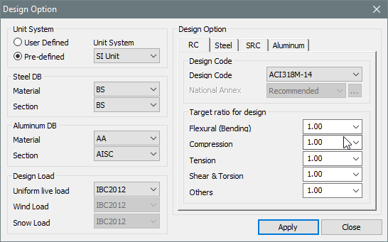

**ECP 203 - 2017**

# Material Properties:

Concrete Grades: 25, 30, 35, 40. 45, 50

Modulus of Elasticity (Es): 4400 Sqrt(fcu)

Tensile Strength of Concrete (Ft): 0.6 Sqrt (fcu)

Rebar Code:

Rebar Grades: 240, 350, 400, 420

Modulus of Elasticity (Es): 240, 350, 400, 420

Steel Modulus of Elasticity (Es): 200,000 MPa

Bar Dia, Area, Weight

# Beam Design Specifications: